

**SCHOOL OF CHEMISTRY**

**SENIOR CHEMISTRY**

**PROJECT C: Intermolecular Forces**

EXPERIMENT A: THERMODYNAMICS OF THE HYDROGEN BONDS IN THE  
 FORMIC ACID DIMER

EXPERIMENT B: COMPUTATIONAL INVESTIGATION OF HYDROGEN BONDING

**CONTENTS**

Page

**Part A:** Thermodynamics of the Hydrogen Bonds in the Formic Acid Dimer 7

**Part B:** Further Investigations of Intermolecular Interactions: 15

Part 1: Computational Investigation of Hydrogen Bonding 16

Part 2: Your own Investigations 30

Appendix for Part 1 33

**Hydrogen Bonding**

***Aim***

The aim of this project is for the student to investigate the intermolecular forces behind many physical and biological phenomena, such as DNA molecular recognition and protein folding.

***Introduction and Background***

Many phenomena observed in everyday life and in the biological world are complicated but can be explained in terms of the principles of *physical chemistry*, and in particular can be attributed to the strength of the interactions between molecules. Intermolecular interactions explain behaviours observed both on the molecular scale and on the *mesoscopic* phenomena, such as surface and colloid science. Intermolecular forces not only explain but also quantify the magnitude of many chemical and physical phenomena, such as: the vapour pressure of liquids and melting temperature of solids, the ability of liquids to spontaneously ﬁll a glass capillary, the secondary and tertiary structure observed in DNA and proteins or the stability of latex particles in a can of paint. Of these intermolecular forces, hydrogen bonding is particularly important in biological systems, for example, the hydrogen bonds in DNA are illustrated in Figure 1 as the “rungs in the ladder’. In this project you will investigate hydrogen bonding.



**Figure 1**: Representation of the hydrogen bonds in DNA.

The project has three parts. The first part involves an infrared analysis of hydrogen bonding in the formic acid dimer, and determination of the experimental enthalpy of a hydrogen bond in formic acid. The second part involves a computational study of hydrogen bonding in the formic acid dimer. The third part of the project is an independent investigation of some aspect of hydrogen bonding. This can be further calculations, experiments you can do with resources at home, analysis of literature.

The first part of the project is assessed via a power point oral presentation, which will be followed by a short question and answer session with the marker for the project. The second part of the project will be assessed via a written laboratory report.

**PART A: THERMODYNAMICS OF THE HYDROGEN BONDS IN THE FORMIC ACID DIMER**

***Aim***

The purpose of this experiment is to determine the enthalpy of dimerisation of formic acid by spectroscopic measurement, thereby determining the strength of the hydrogen bonds between the formic acid monomers.

***Introduction and Background***

Hydrogen bonds are a special class of intermolecular interaction which gives rise to the speciﬁc molecular recognition seen in protein folding, and the DNA double helix. Intramolecular hydrogen bonds are responsible for the *α*-helix and *β*-sheet structures in proteins while the base-pair–base-pair recognition in DNA is an intermolecular interaction utilising either three (between guanine, G, and cytosine, C) or two (between adenine, A, and thymine, T) hydrogen bonds.

Carboxylic acid molecules are strongly associated, even in the vapour phase, by a pair of hydrogen bonds. Many years ago, it was shown by electron diﬀraction that formic (methanoic) acid vapour contained, in addition to the monomer, a signiﬁcant concentration of a planar dimeric form, stabilised by two hydrogen bonds as shown in Figure 1.

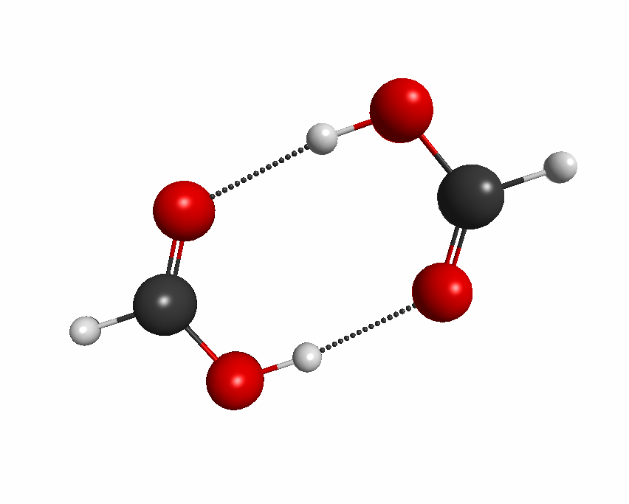**Figure 1:** The symmetricplanar structure of the formic acid dimer. Carbon atoms are shown as black,   
oxygen as red and hydrogen as white.

The formic acid monomers and dimers are in equilibrium according to the reaction

$2HCOOH⇌{(HCOOH)}_{2}$ (1)

which is exothermic as written. Writing *D* for the dimer and *M* for the monomer, the equilibrium constant *KD* for partial pressures for the dimerisation reaction is

$K_{D}=\frac{P_{D}}{P_{M}^{2}}$ (2)

The monomer and dimer have diﬀering vibrational frequencies so that the infrared (IR) spectrum of formic acid vapour should exhibit frequencies associated with both dimer and monomer. Provided the frequencies associated with the two components can be identiﬁed and isolated, Fourier Transform Infrared (FTIR) spectrometry can be used to determine the concentrations of both dimer and monomer as a function of temperature. From this information both *KD* and the standard enthalpy of dimerisation, ∆ $H_{D}^{0}$, can be determined.

From Equation 2 it may be seen that the dimer partial pressure or concentration will increase quadratically with increase in partial pressure of the monomer. Thus, an increase in sample pressure of formic acid would be expected to increase the dimer partial pressure relative to that of the monomer and hence increase the intensity of the dimer absorption bands in the IR relative to those of the monomer. Therefore, by varying the sample pressure it should be possible to distinguish the dimer bands from the monomer bands in the FTIR spectrum.

Since Equation 1 is exothermic as written, an increase in temperature should cause a shift to the left and hence favour production of monomer over dimer. Thus, by observing the decrease in the ratio of the dimer/monomer bands in the IR as a function of temperature, the variation of *KD* with temperature, *T*, can be obtained and hence ∆ $H_{D}^{0}$ can be determined. The enthalpy of dimerisation is a direct measurement of the strength of the hydrogen bond (or in this case, the two hydrogen bonds that are formed).

We assume that formic acid vapour obeys the ideal gas law so that the partial pressures of dimer and monomer are given respectively by *PD* = [*D*]*RT* and *PM* = [*M*]*RT*, where [*D*] and [*M*] are the dimer and monomer concentrations, respectively, *R* is the ideal gas constant and *T* is the temperature. We further assume that Beer’s law is obeyed for IR absorption by the formic acid vapour,

*A* = *εcl,* (3)

*i.e.*, absorbance is proportional to concentration, *c*, and pathlength, *l*, of the IR cell. The constant of proportionality, *ε*, is the molar extinction coefficient and is related to the intensity of the absorption. Let ⟨*D*⟩ and ⟨*M*⟩ represent the integrated absorbances of a completely resolved IR absorption band of the dimer and monomer, respectively. *εD* and *εM* are then the absorption coeﬃcients of these two bands. Then *KD* is given by

$K_{D}=\frac{P_{D}}{P_{M}^{2}}=\frac{[D]}{{\left[M\right]}^{2}RT}=\frac{〈D〉}{{〈M〉}^{2}T}\left(\frac{ε_{M}^{2}l}{ε_{D}R}\right)$ (4)

For ideal gases, the Gibbs Free Energy, *G*, is related to pressure by

$G=G^{0}+RT ln\left[\frac{P}{P_{0}}\right]$ (5)

where *P*0 is the pressure in the standard state (1 atm ~ 1 bar). It follows that,

$ΔG_{D}^{0}=-RTlnK_{D}=ΔH_{D}^{0}-TΔS_{D}^{0}$ (6)

Equation 4 can be rearranged to

$\ln\left(\frac{〈D〉}{{〈M〉}^{2}T}\right)=-\frac{ΔH_{D}^{0}}{R}∙\left(\frac{1}{T}\right)+\left[\frac{ΔS_{D}^{0}}{R}-\ln\left(\frac{ε_{M}^{2}l}{ε_{D}R}\right)\right]$ (7)

Thus, if the quantity on the left hand side of Equation 7 is plotted against 1*/T*, then ∆ $H_{D}^{0}$, and hence the enthalpy of the two hydrogen bonds that are formed in the formic acid dimer, can be determined from the slope. Note that in the above equation, the units of *R* should be chosen such that *RT* is in J.mol*−*1. The *R* contained in Equation 4 must also reﬂect the units of pressure, for example, in atm (or bar). However, this *R* is in the intercept of the plot and does not enter the calculations below.

***Experimental Results***

The experimental FTIR spectra provided to you in a spreadsheet ASCII (*.asc) files have been obtained by a student in the teaching laboratory using a thermostatted stainless steel 10 cm absorption cell equipped with KCl windows, a vacuum valve and couplings, a thermocouple port and a septum port.

**1. Background Spectrum**

The heatable IR cell was evacuated and purged several times with dry nitrogen before being filled with dry nitrogen to one atm pressure. The cell was placed in the FTIR sample compartment and the heater and thermocouple cables connected to a temperature controller. The cell was allowed to equilibrate to a temperature of 30 *°*C. A background spectrum of dry nitrogen was obtained at a spectral resolution of 2 cm*−*1, from 64 scans at a temperature of 30 *°*C.

**2. FTIR Spectra of Formic Acid**

Low Pressure Spectrum A microlitre (0-1 *µ*L) syringe was used to inject 0.3 *µ*L of liquid formic acid through the septum port into the cell. After waiting five minutes, which was used to ensure the liquid formic acid had vaporized and equilibrated within the cell, a vapour spectrum was obtained at 30 *°*C at a spectral resolution of 2 cm*−*1, from 128 scans. This spectrum is shown in Figure 2 below.

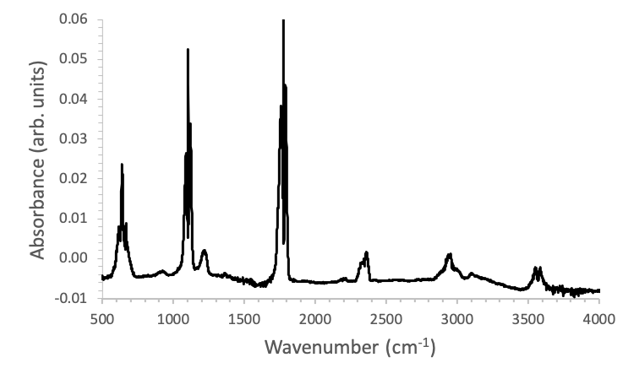

**Figure 2:** The ‘low pressure’ IR spectrum of the formic acid and its dimer.

High Pressure Spectrum A further 0.9 *µ*L of formic acid liquid was then injected into the cell through the septum such that the cell contained a total of 1.2 *µ*L of formic acid. After five minutes for equilibration, an FTIR spectrum was obtained at 30 *°*C. This spectrum was run for only 8 scans (*i.e.*, 128*/*42) so that it maintained the same signal-to-noise ratio as for the ﬁrst sample which was only 1/4 as concentrated. A simple (but approximate) check is to compare the ratio of the peak heights in the low and high pressure spectra reﬂects. The high pressure spectrum had the same spectral resolution of 2 cm*−*1. This spectrum is shown in Figure 3 below.

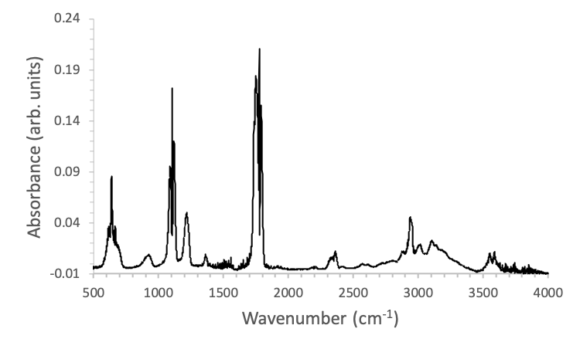

**Figure 3:** The ‘high pressure’ IR spectrum of formic acid and its dimer.

**3. Spectra at Diﬀerent Temperatures**

With the cell remaining in the IR sample compartment, its temperature was increased and 6 additional spectra were taken between 30 and 60 *°*C, as shown in Figure 4.

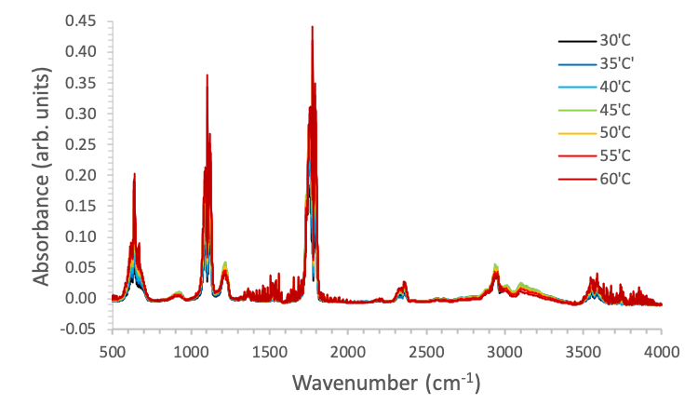

**Figure 4:** The ‘IR spectrum of formic acid and its dimer as a function of temperature, as indicated.

The data for these spectra are available in spreadsheet ASCII (*.asc) files.

***Data Analysis***

You can analyse the spectra using a number of different applications, for example, Microsoft Excel, or Spectrum for Windows.

For the two diﬀerent initial concentrations of formic acid studied at 30 *°*C, display both spectra on the same plot. Although the absorbance of the run done at the higher initial concentration is always greater than for the lower concentration, some of the bands for the higher concentration will be seen to have increased by a greater ratio than have other bands. Those bands which have the greater increase in ratio are the bands due to the dimer. Thus, identify the monomer and the dimer bands. Despite the initial concentration of formic acid being increased by a factor of 4, the ratio *RM* = ⟨*M*⟩*higher /*⟨*M*⟩*lower* is less than 4 because this ratio depends on the value of *KD* and on the total amount of monomer + dimer present in the system. However,

$\frac{{〈D〉}_{higher}}{{〈D〉}_{lower}}={\left(\frac{{〈M〉}_{higher}}{{〈M〉}_{lower}}\right)}^{2}$ (8)

This may be best seen by expanding the wavenumber scale to observe the two spectra between about 1300 and 1000 cm*−*1.

If now the lower pressure spectrum is multiplied by the factor *RM* (this factor can be obtained approximately from the ratios of the absorbances at the maxima of the monomer bands) and subtracted from the high pressure spectrum, the monomer spectrum should be completely cancelled out and the remaining spectrum is that of the dimer alone. Carry out this procedure and use it to plot the spectrum of the dimer. Return to the original two spectra. If the low pressure spectrum is multiplied by $R_{M}^{2}$ and subtracted from the high pressure spectrum, the dimer contributions should be cancelled out. However, in this case the monomer spectrum will appear as a negative residual spectrum. Plot this (“negative-going”) monomer spectrum.

Examine the “pure” monomer and dimer spectra you have just obtained, as well as the high pressure spectrum of the mixture and ﬁnd non-overlapping bands in the mixture spectrum which can be unambiguously assigned either to the dimer or monomer alone. [*Hint:* These bands will be found in the expanded region 1300-1000 cm*−*1 and are associated with the C-O-H in-plane bend of the dimer and the monomer.] Once you have located a non-overlapped monomer and non-overlapped dimer band, use these two bands to carry out the remainder of the analysis on the high pressure spectra at all ﬁve temperatures.

It will be necessary to ﬁnd the integrated absorbances (areas) of the chosen monomer and dimer bands in the spectra taken at each temperature. To do this you will have to integrate the area under the bands so it is necessary to locate the beginning and ending wavenumbers of the band and the position of the baseline. The Spectrum for Windows program allows an automatic baseline correction, where any drift in the baseline with wavenumber is accounted for. Alternately, you can do this manually in a spreadsheet program like Excel.

Determine the integrated absorbances ⟨*D*⟩ and ⟨*M*⟩ at each temperature for the higher pressure mixture.

*Note:* you must integrate the entire rotational contour of the IR absorption band; each vibrational transition is accompanied by a range of possible rotational transitions which give characteristic rotational structure to the IR absorption. The wavenumber range to integrate should be clear from your “pure” monomer and dimer spectra but if you are unsure please check with a demonstrator.

Prepare a table of the integrated absorbances and the quantity ln(⟨*D*⟩*/*⟨*M*⟩2*T* ) as a function of *T*. Plot ln(⟨*D*⟩*/*⟨*M*⟩2*T* ) as a function of 1*/T* . From the slope of this curve determine the standard enthalpy of dimerisation of formic acid.

***Results***

You should pay attention to clarity, so that the required information is presented as coherently and concisely as possible. All numerical results should include units, where appropriate, and experimental uncertainty. For further details on the calculation of uncertainties, please refer to the data analysis handbook. Where possible you should compare your results with values from the literature. Your results should comprise:

1. The “pure” formic acid monomer and dimer spectra (these can be in the same figure) over the appropriate wavenumber range, with a justification of this range.
2. A clearly labeled publication quality figure containing the high pressure IR spectra at the five temperatures considered.
3. A publication quality table containing ⟨*D*⟩, ⟨*M*⟩ and ln(⟨*D*⟩*/*⟨*M*⟩2*T* ) as a function of *T* and 1*/T.*
4. A publication quality plot and linear regression analysis of ln(⟨*D*⟩*/*⟨*M*⟩2*T* ) as a function of 1*/T.*
5. Your calculated standard enthalpy of dimerisation, ∆ $H_{D}^{0}$, and enthalpy of a hydrogen bond, with errors.
6. The entropy of dimerisation ∆ $S_{D}^{}$ can be obtained from Chao and Zwolinski (Reference 1) as –165.1 J.K-1.mol-1 at 300 K. Use this value and your ∆ $H_{D}^{0}$, to calculate the equilibrium constant for dimerization *KD* at 25 oC and 60 oC. Use this value to determine whether dimerisation is spontaneous under the experimental conditions you examined.

Please make sure you include appropriate and informative figure captions and table headings, and pay careful attention to figure formatting, in particular to units and axis labels. Details on how to prepare publication quality figures and tables can be found in the ACS Style Guide.

***PowerPoint Presentation***

You will be required to prepare and deliver an *Oral PowerPoint (or equivalent) Presentation* which will be followed by a short question and answer session with a marker assigned to that project. These will be held in week 8 (for First Rotation) and week 13 (for Second Rotation) using Zoom.

For an *Oral Presentation Submission* you are required to:

1. Prepare a 5 minute oral presentation which you will present to the marker via Zoom. *See below for more details on file formats and what your presentation should include.*
2. Submit a pdf your presentation file via Canvas by 10.00 am on Monday of either week 8 (first rotation) or week 13 (second rotation).
3. Join a Zoom meeting at your allocated presentation time, deliver your presentation to the marker, and answer their questions about your experiment.

You will be assessed on your ability to communicate your ideas clearly and accurately, and to demonstrate your understanding of the experiment that you have completed.

***It is your responsibility to attend your allocated Zoom session. If you do not attend you will receive a mark of 0 for this assessment component (except when Special Consideration is sought and granted).***

***Please note that the University’s Academic Honesty in Coursework Policy applies to all submissions****.* The full policy can be found on the University’s policy website: [*http://sydney.edu.au/policies*](http://sydney.edu.au/policies)*.*

**Guidelines for Oral Presentations**

Your presentation should be approximately 5 minutes long. A presentation of this length would reasonably comprise 4–8 slides. It should be prepared in either Microsoft PowerPoint, PDF (Portable Document Format) or equivalent format and you should present it by sharing your screen within Zoom. Note, however, that submissions to Canvas are only allowed in pdf format.

Your presentation should include the following:

1. A **TITLE** slide that accurately, clearly, and concisely reflects the emphasis and content of the presentation. The title must be brief and grammatically correct.
2. **S.I.D.** of every group member.
3. **AIMS**: a brief statement of the purpose of the research. You should try to identify what scientific information is being gathered and/or what hypothesis is being tested.
4. **EXPERIMENTAL METHODS**: A brief consideration of the key technique(s) used in your experiment. Here this is IR spectroscopy, so describe how it can be used to study hydrogen bonding in the formic acid dimer. You should also justify the wavenumbers you used to assign the non-overlapping monomer and dimer absorptions you analysed.
5. **RESULTS & DISCUSSION:** The key findings of your experiment, as listed above. What was interesting/important about them? Did they support your hypothesis? Comment on the quality of the data obtained by the student in the teaching laboratory.
6. **CONCLUSION**: Draw your discussion to a close by considering the significance of your results in the context of the entire experiment. Are any other experiments required to validate your data? If you were to take this work further, what would be the next step(s)?

You are free to include animations and other visual effects in your presentation as you deem appropriate.

In preparing your presentation you should pay attention to clarity so that the information is presented as coherently and concisely as possible. Numerical results should include experimental uncertainty.

***References and Further Reading***

1. J. Chao and B. J. Zwolinski, J. Phys. Chem. Ref. Data 1978, 7, 363 and references therein. (in computer room and on blackboard).
2. P. W. Atkins, Physical Chemistry, 6th Ed. Oxford University Press (1998).
3. <http://www.chem1.com/acad/webtext/thermeq/TE5.html>

**Part B FURTHER INVESTIGATIONS OF INTERMOLECULAR INTERACTIONS**

This experiment is in two parts. The first is a computational investigation of the hydrogen bonding. This, combined with your results from Part A, will give you further insight into the nature of hydrogen bonding in the formic acid dimer, and hydrogen bonding in general. The second part of the experiment involves “student-led enquiry” where you will choose another experiment to perform and you will design your own experimental procedure. A number of suggested avenues are given at the end of Part 1, but you are not limited to these. **Before beginning Part 2**, you should check with a demonstrator that your proposal is sensible and, if you are planning an experimental investigation, even at home, you need to check its feasibility and that it can be performed within an appropriate time-frame, prepare a HIRAC and have this signed off by an academic member of staff.

***Assessment Details***

* This experiment will be assessed on the basis of an *investigative report*, as outlined at the end of the experimental notes, to be submitted through Canvas.
* Check the Canvas site for further details of due dates and submission deadlines.

**PART 1: COMPUTATIONAL INVESTIGATION OF HYDROGEN BONDING**

The aim of this part of the experiment is to run quantum electronic structure theory calculations using the Q-Chem electronic structure program. You will use an interface called IQmol to help write the input files and visualise the output. IQmol will also submit your jobs to be calculated and manage the resulting output files. By following these instructions, and gaining assistance where required, you will learn how to operate the software and calculate molecular structures, energies and infrared spectra. Your results will help you understand the nature and characteristics of the hydrogen bonds in the formic acid dimer and of hydrogen bonds in general.

***Experimental Method***

**1. Download IQmol:** <http://iqmol.org/downloads.html>

This is free and you can select a binary file to install for Mac (OS X), Windows or Linux. The install comes with a pdf IQmol user guide, which has additional instructions for installation, if needed as well as more detailed instructions for calculating and visualizing molecular properties.

* 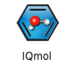For Mac (OS X) a disk image is provided. After downloading, copy this to your Applications folder and double-click it to open.
* For Windows an installer is provided that will guide you through the installation process and will also create a shortcut to the application on your desktop.
* Instructions for the linux install are on the download page and in the IQmol user guide. It will require sudo privileges.
* If you are super keen to see how everything works you can download the source code from GitHub (link is on the download page)

**2. Open IQmol:**

Double click IQmol to open the main IQmol window:

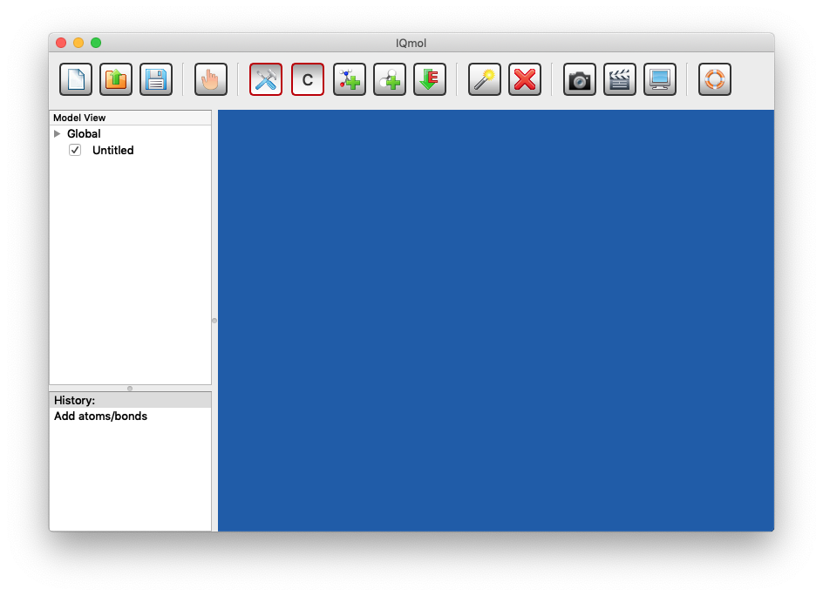

The blue section is the molecule **viewer** window, there is a **toolbar** in the upper banner, which has common commands as buttons. On the left is the **Model View** panel, which shows data available for the molecule, and the **History** panel, which shows the most recent actions. Note that you can undo actions by using “cmd/cntrl-z” Mac/Windows, or from the top **Edit** menu pulling down to > **Undo**.

**3. Make a Molecule**

IQmol will open in “build” mode by default. This is indicated by the red borders around the build and atom buttons in the toolbar shown below. The “C” indicates the default build atom is a carbon atom.

* In build mode, when your cursor is over the blue window it will change to a black hammer and clicking in the molecule view window creates a carbon atom:

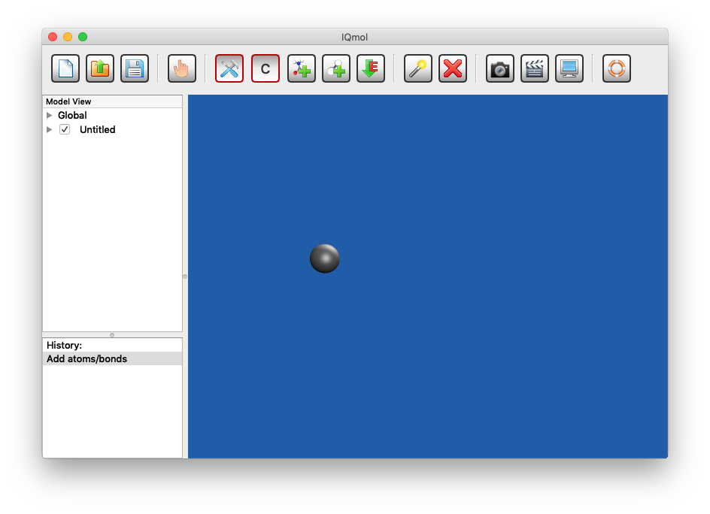

* To make formic acid, click on the atom select button, which will bring up a periodic table, and select oxygen:

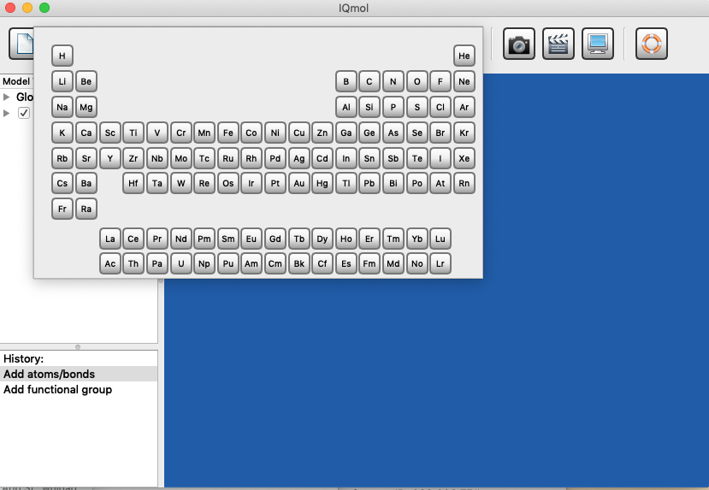

* Now click on the carbon atom and drag your mouse to create a carbon-oxygen bond:

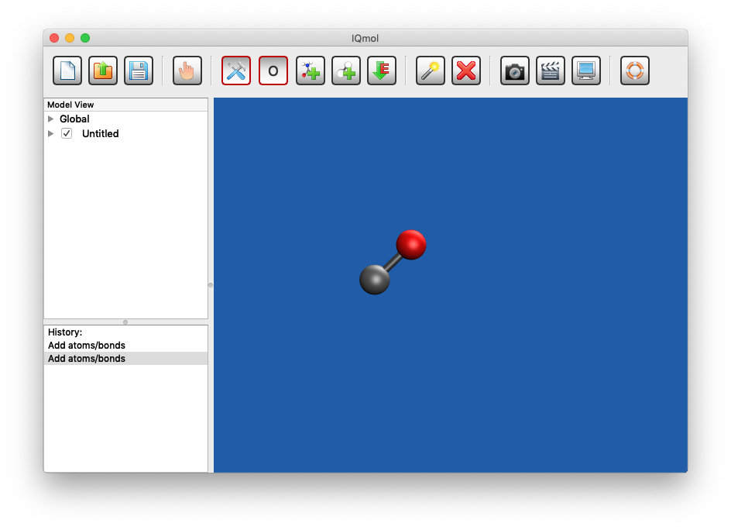

* To change the bond order, click on the carbon and drag your cursor out to the oxygen:

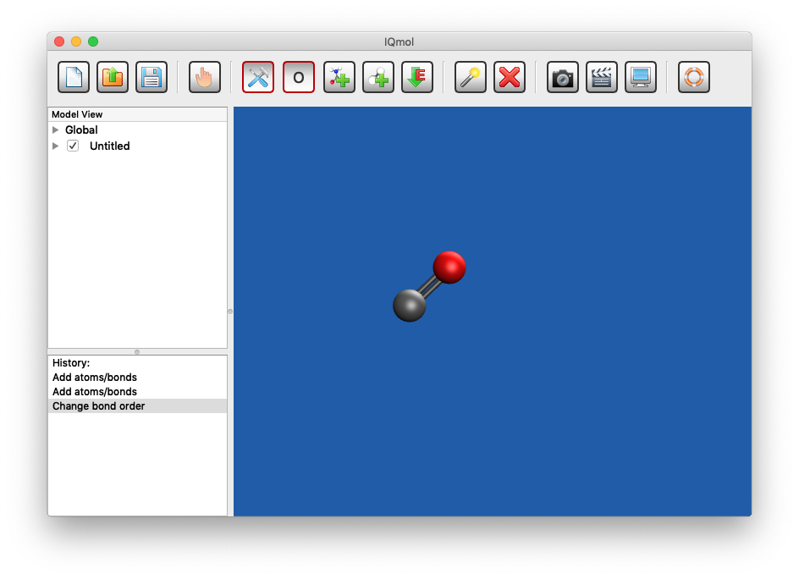

* Make a second carbon-oxygen bond by clicking on the carbon and dragging the cursor out, an approximately 120º angle to the C=O:

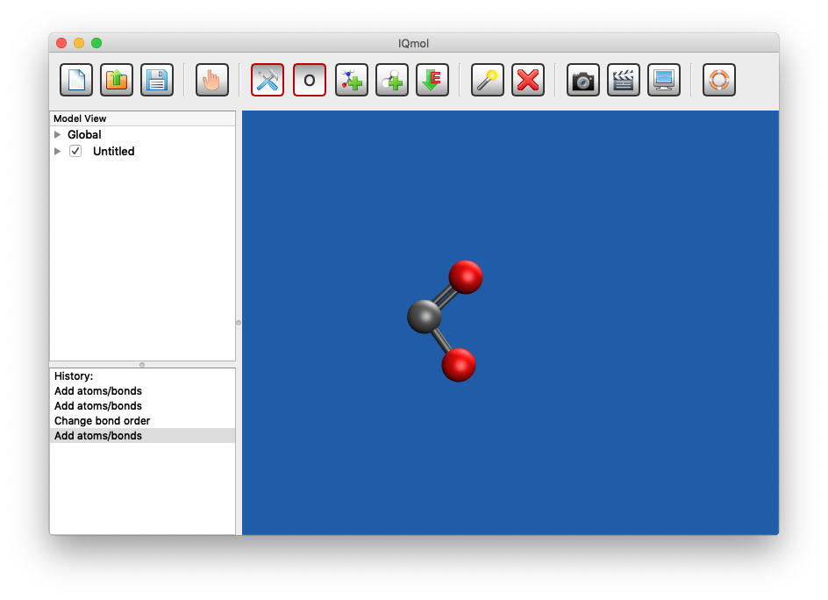

* To add hydrogen atoms, you could either use the periodic table to select “H” and draw the bonds with your mouse, or you could click the “Add Hydrogens” button, , to give:

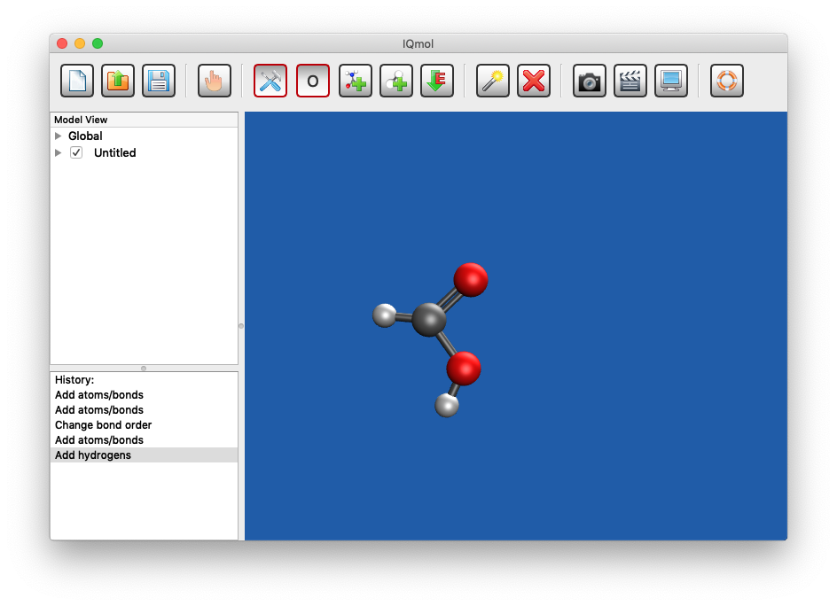

You have now drawn formic acid! Mine isn’t look too bad, yours might be a bit wonky…

* “Clean up” your structure by doing a molecular mechanics force field optimization. This uses the “Universal Force Field” (UFF) to optimize bond lengths, bond angles and torsional angles (out of plane angles) using standard descriptions of things like C=O bonds etc. To do this, click on the **minimize energy** button, . I obtained:

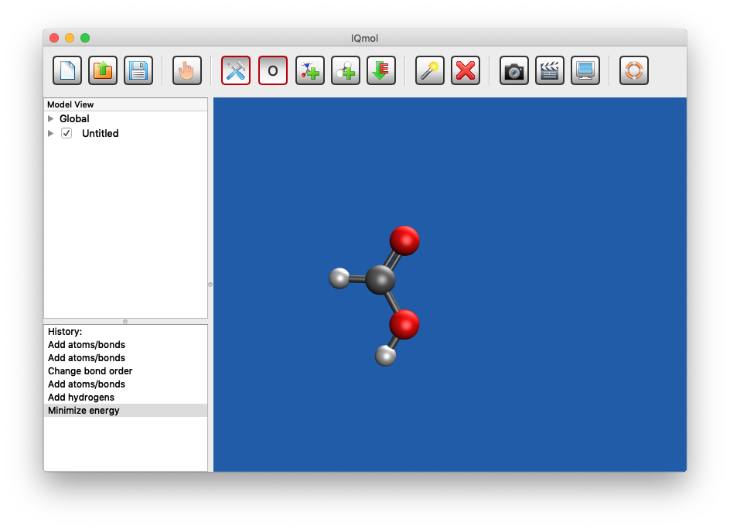

* For most molecules this is OK but UFF notably does not include hydrogen bonding. You can change the force field using the top **Build** menu, for example Build > Select Force Field > MMFF94:

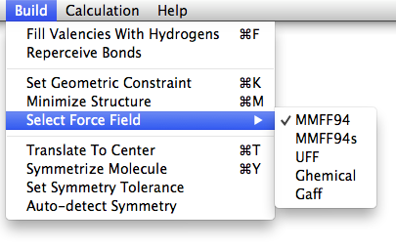

* Reoptimising formic acid using the MMFF94 force field changes it a little:

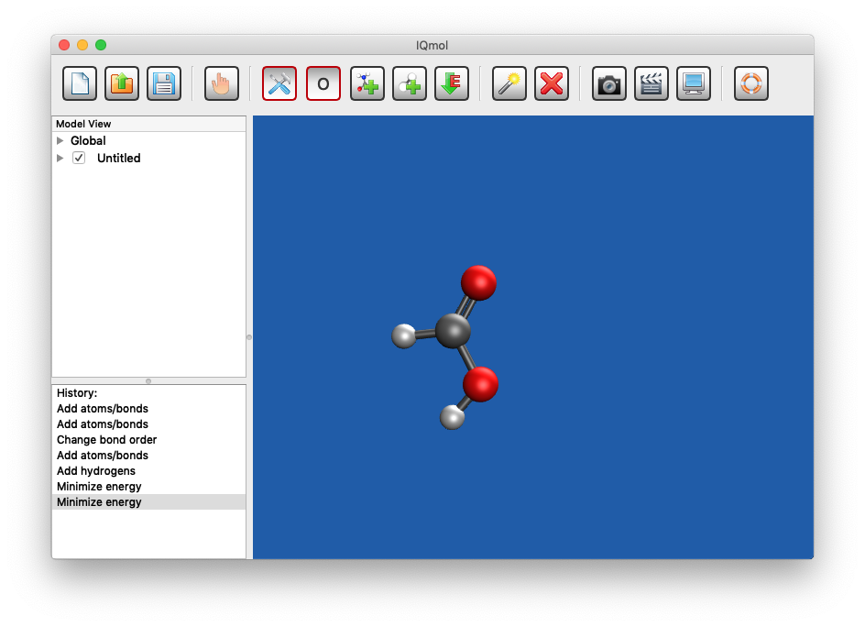

You will, however, notice very big differences between UFF and MMFF94 for the formic acid dimer!

You can manipulate your view of the molecule using the **hand** button, , in the tool bar (see section 2.5 of the manual).

* The default version of formic acid shown in the molecule view window has the O-H in a *syn* conformation to the C=O. Whilst this is a stable conformer, it is not the most stable conformer so you will need to change the torsional angle defining where the O-H H atom is.
* Use the select button, , and then click on 4 atoms ending with the O-H H atom, I’ve clicked the double bonded oxygen, then the carbon, then the O then the H. The four atoms you have selected will be shaded red (with varying intensity from first to last).
* Go to **Build > Set Geometric Constraint** which will open a dialogue box where you want to constrain the torsional angle by typing 0 over the existing torsional angle of 180º. That is:

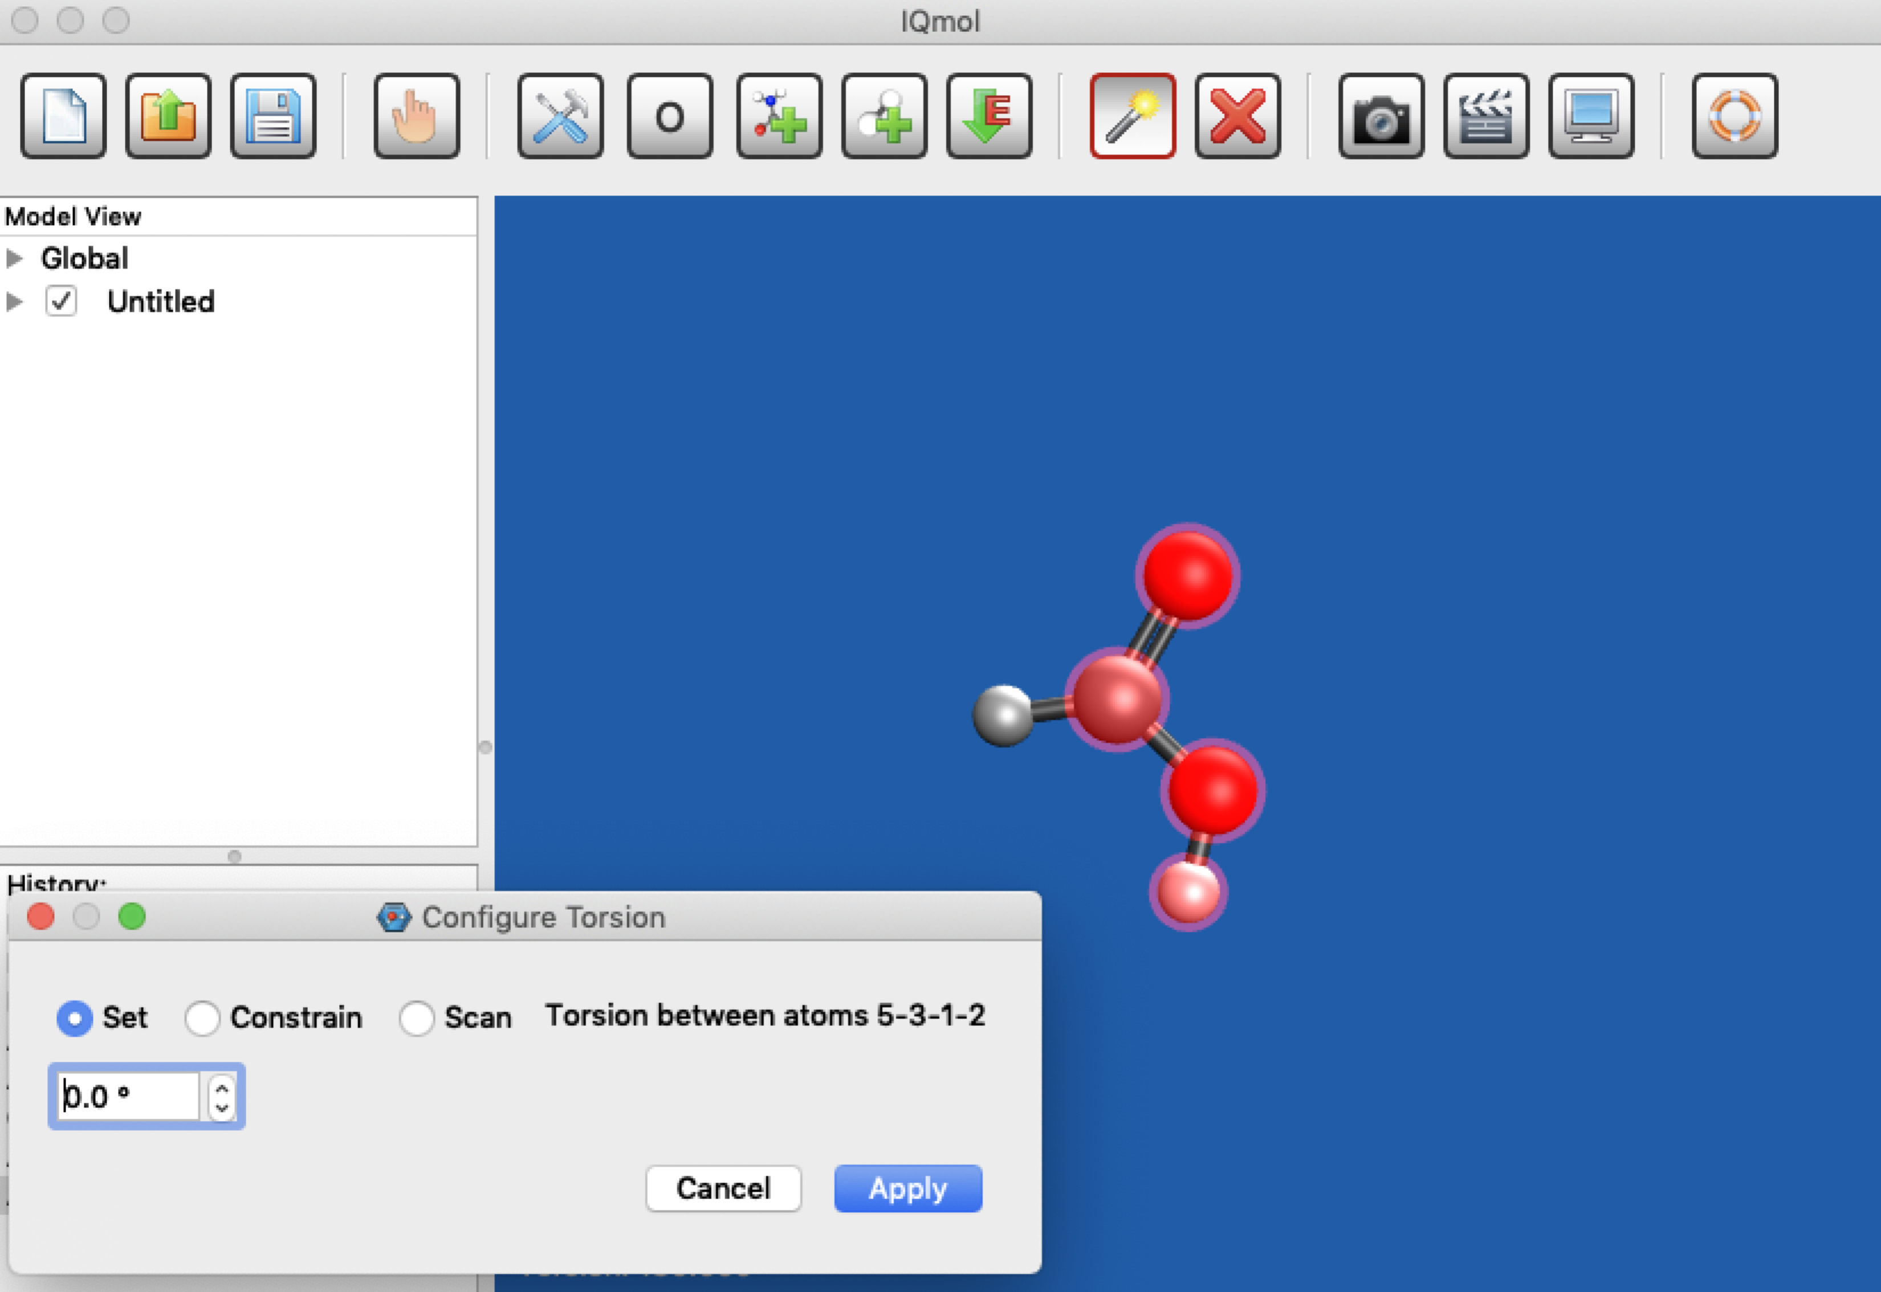

* When you **Apply** this constraint, the O-H bond will rotate, and on reorienting your molecule you should get something like this:

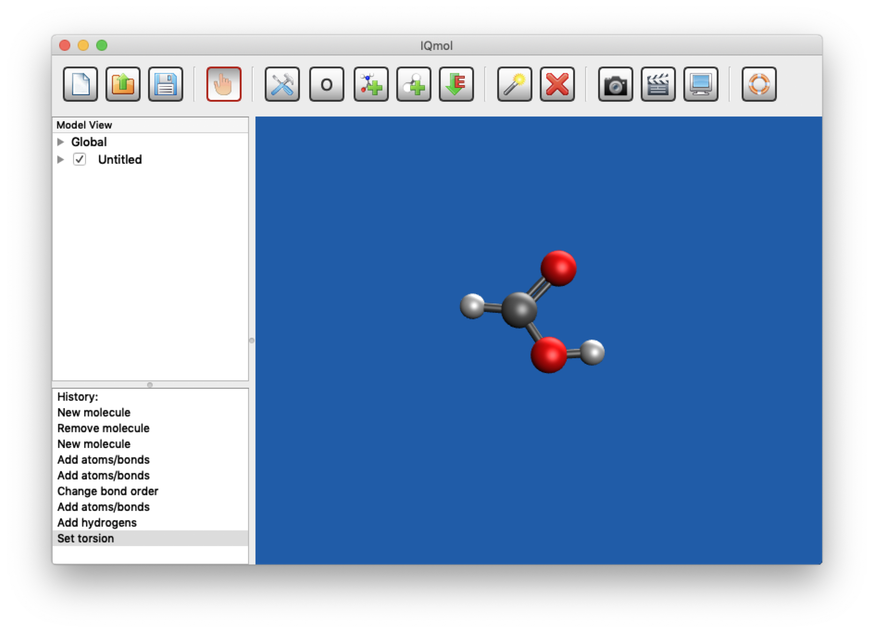

**4. Setting up a Q-Chem Calculation:**

To run a quantum chemical calculation, you need to make an input file. Use, from the top menu **Calculation > Q-Chem Setup** to open an input builder window:

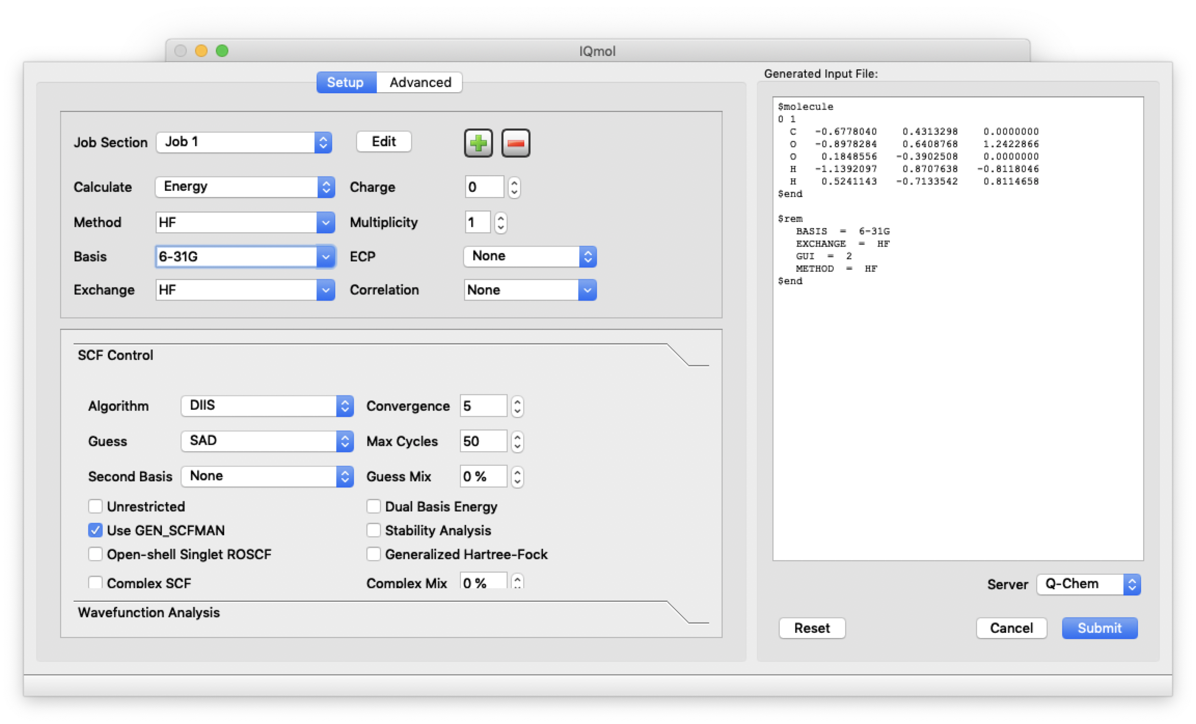

The panel on the left is for specifying the calculation you want to run and the input file that is generated from your instructions is shown on the right. The default options run a single job, Job 1”, that calculates the Hartree-Fock (HF) Energy for the geometry showing in your molecule view window. By default, an uncharged “singlet” state molecule with “Multiplicity 1” is assumed. This means that all of the electron spins are paired in the molecule and there is equal number of up and down spins. There is only one way to do this so the electrons in the molecule have multiplicity “1” (radicals have an unpaired electron and there are two ways to do this, the unpaired spin could be up or down, so radicals have multiplicity “2”). By default, the 6-31G basis is assumed and the other options pertain to how the HF calculation will be run.

* Use the pull-down menus to change Job 1 to Calculate the “Geometry”
* Change Basis to “6-31+G*”. This basis is equivalent to 6-31+G(d) and has diffuse basis functions on the carbon and oxygen atoms and uses the shapes of atomic *d* orbitals to polarize the orbitals on the carbon and oxygen atoms when they are used to make molecular orbitals.
* Leave all the other options as they are. Your ‘Job 1’ window should now look like:

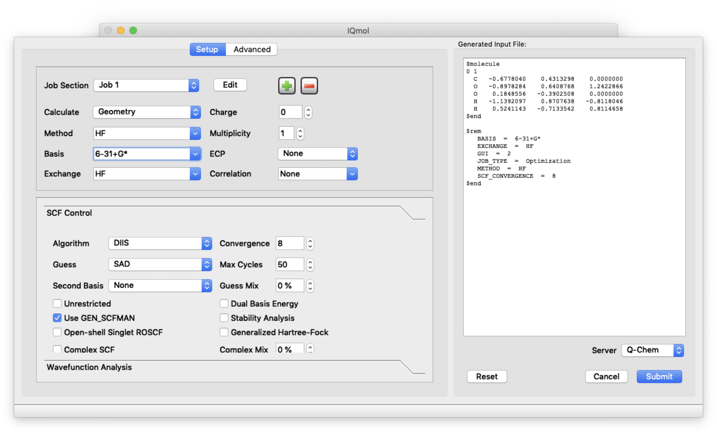

* Job 1 will optimize the geometry of formic acid, now click the  button to add a second Job and pull down the **Job Section** tab to edit Job 2.
* Select **Calculation > Frequencies** and leave the other boxes the options as they are:

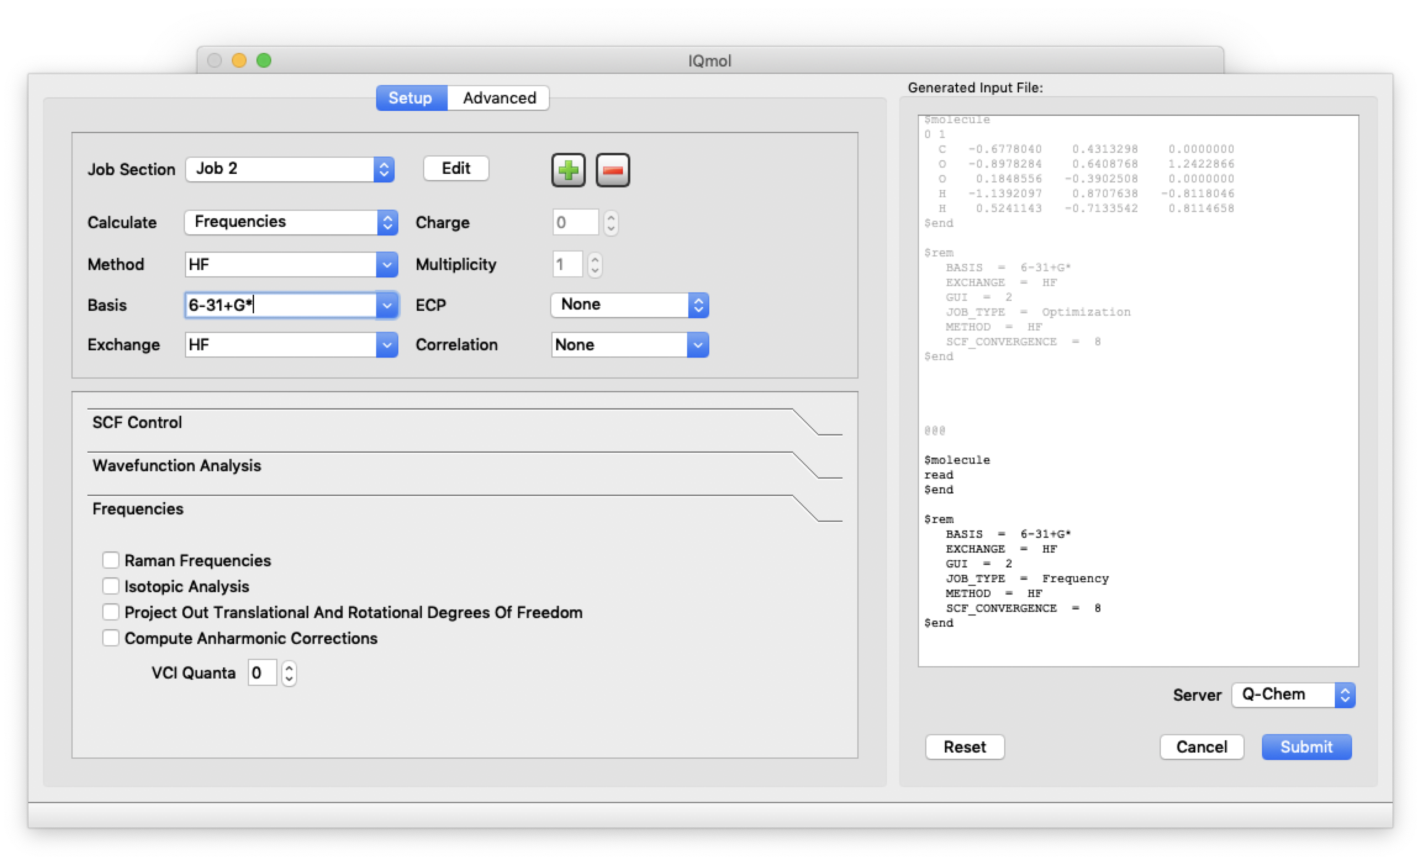

* Job 2 will run a vibrational frequency calculation on your optimized geometry.

**5. Running a Q-Chem Calculation:**

* Press the Submit button. This submits your job to the Q-Chem server, which is located in California. Note: this server has a 10 minute time limit for any calculation you submit.
* A window will open asking you for a **Job name**. Call your calculation something sensible and submit it. I called my job “formic acid MJ”. You can monitor your job using the job monitor window: **Calculation > Job Monitor**. Note that Job Monitor lets you kill the job if you ‘ve made a mistake… Right Click and **Kill Job…**

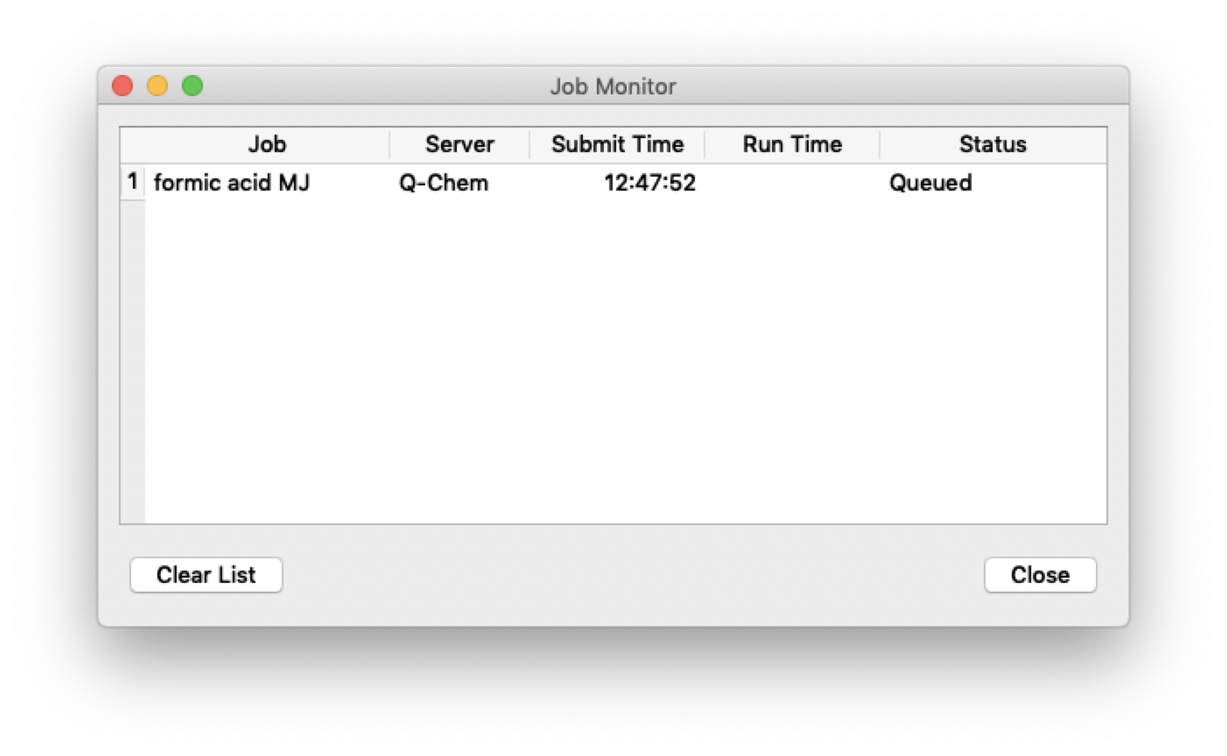

* IQmol will tell you when your job is finished and ask if you want to copy the results from the Q-Chem server. Click **Yes** to save your results to an appropriate directory.

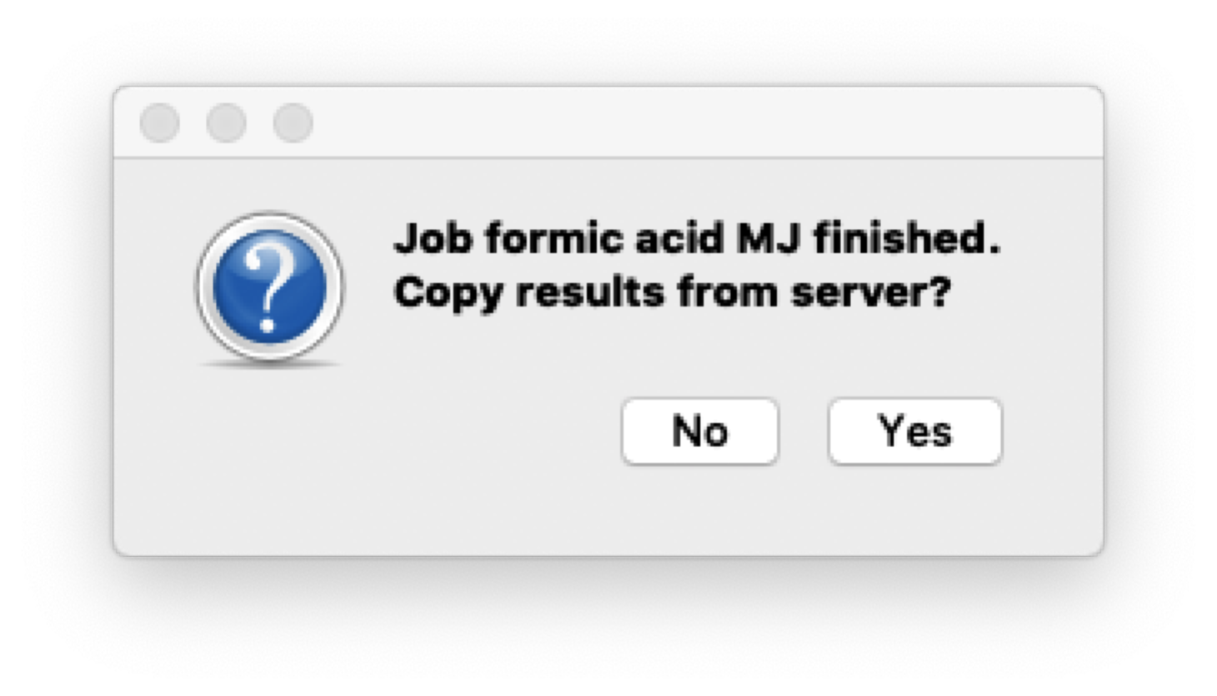

You can look at the output file that was generated using a text editor, such as Text Edit (Mac), Note Pad or Word Pad (Windows). Just use “**open with**” to select a text editor. You can also look at the Q-Chem output within IQmol by right clicking the job in the Job Monitor window and selecting **View Output File**.

* If your job does not complete successfully (no gold star, , in the Model View panel) you will get a brief message pop up. You can also open and look at the very end of the output file to determine what went wrong. If it is not an obvious fix, please ask for help!

**5. Viewing Results:**

If your job completed successfully, a gold star, , will appear next to your job name in the Model View panel. This indicates that IQmol has been updated with the results of your calculation.

* To view the results of your calculation, Click on the ▶arrow next to your job name.
* For example, clicking on **Geometries** shows 8 energy values indicating that my optimization job took 7 steps to optimize the geometry of formic acid and then the 8th energy was calculated for the vibrational frequency job, job 2. The energy gets lower as I read down the list. The top energy corresponds to my initial starting geometry and the bottom (two) energy values to my final optimized electronic energy
* You can also find this optimized electronic energy by opening the output file and looking for “Final energy”, that is:

Final energy is -188.7691845904

* Clicking on the individual energies in the list shows you how the geometry corresponding to that energy and you can see how the geometry changes at is optimised.
* Click on the final energy to see the optimized geometry. I have rotated it to obtain:

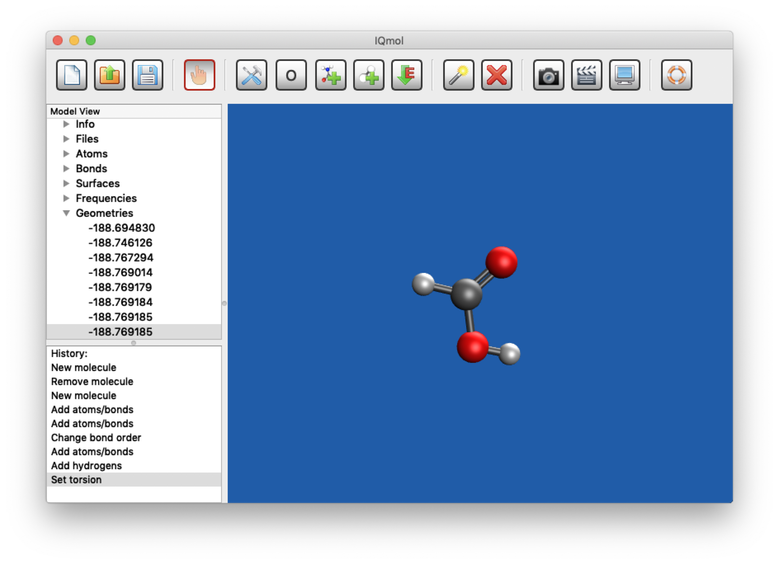

The optimized electronic energy from this calculation is given as -188.769185. This is in atomic units of energy (called Hartree, EH). **One Hartree is 2625.6 kJ/mol**. Your energy is negative because +ve protons and –ve electrons attract each other (attraction is negative energy) and this attraction outweighs the nuclear repulsion term (which is why the molecule is stable). The value of the energy is huge in kJ/mol because the distances involved are tiny and the charges are large. The value of -188.769185 EH is the total energy of a single optimized formic acid molecule at the “HF/6-31+G*” level of theory. In practice, isolated electronic energies are not meaningful and instead we consider energy differences. We are going to look at the energy difference between the formic acid dimer and two isolated formic acid molecules.

* You can determine optimized bond lengths etc. by clicking on the ▶arrow next to **Atoms** and clicking and shift-clicking two or more atoms for bond lengths, angles and torsions.
* You can also open the output file to find the Cartesian coordinates of your optimized formic acid molecule. You should see something like this:

Coordinates (Angstroms)

ATOM X Y Z

1 C -0.1365960774 -0.4277617836 0.0000000000

2 O -1.1666436808 0.1550821708 0.0000000000

3 O 1.0553999757 0.1441023321 0.0000000000

4 H -0.0418913779 -1.5063384168 0.0000000000

5 H 0.9524846479 1.0921462883 0.0000000000

* You can click on the ▶arrow next to **Surfaces** to look at the molecular orbitals of formic acid, have fun and explore your formic acid molecule
* Click the ▶next to **Frequencies** to get a list of the calculated frequencies in cm-1:

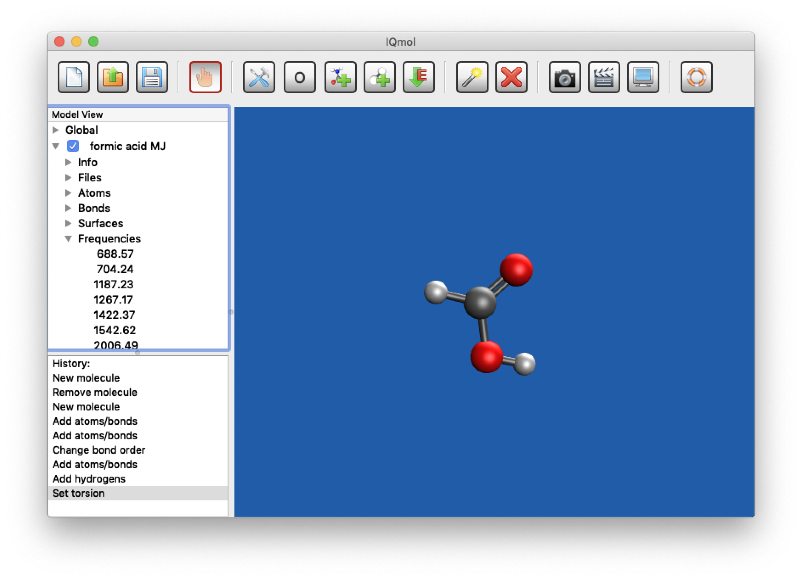

For my job, the lowest frequency was 688.57 cm-1, followed by 704.24 cm-1, etc. The key thing to look for is that all of these numbers are positive – this means they are real frequencies and indicate that a minimum energy structure has been successfully found. A transition state has one complex frequency, which is indicated with a negative sign.

You can examine the vibrations by clicking on their frequencies. For example, clicking on the 688.57 cm-1 vibration shows you pink arrows indicating the normal mode vectors and double clicking animates the vibration:

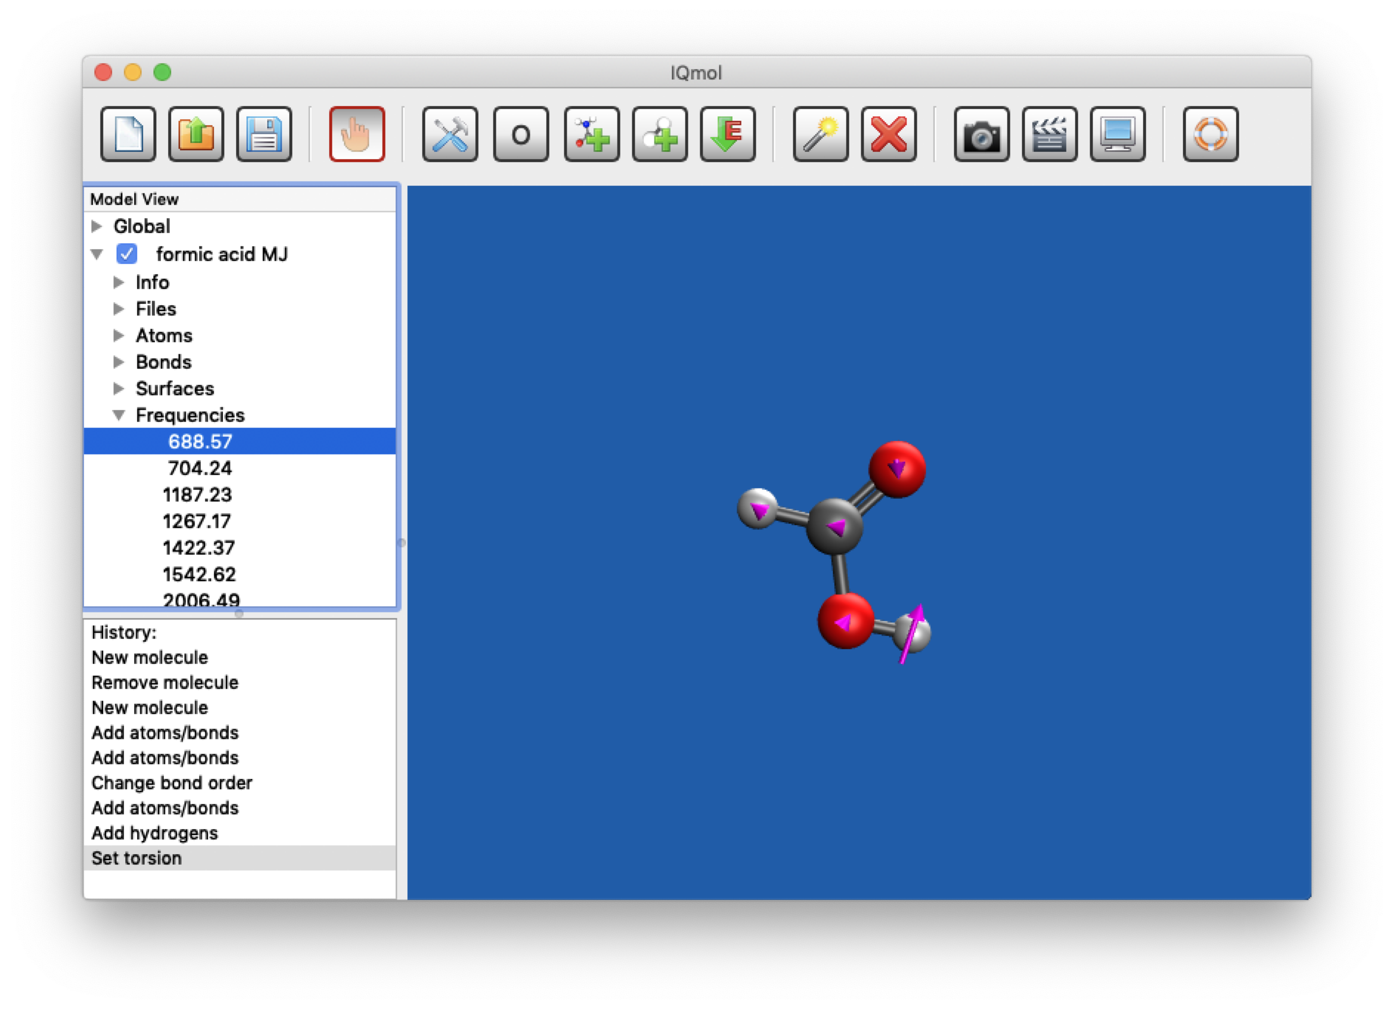

Here the 688.57 cm-1 vibration is an in-plane OCO bending vibration.

* **If** you have a large imaginary (negative) frequency then the structure is a transition state. Animate the motion associated with this frequency. To find a minimum energy structure you need to lower the energy and hence you need to distort along the direction of this motion. For example, if your molecule is non-planar and the motion associated with the imaginary frequency is motion toward (and away from) planarity, distort your structure to make it closer to being planar. Now make a new input file and submit it to optimise the formic acid structure again. Once optimized, hopefully to a *different* structure, calculate the vibrational frequencies again and check they are all real numbers.
* If you double click the word **Frequencies** in the Model View panel, it will bring up the **Vibrational Frequencies** dialogue box:

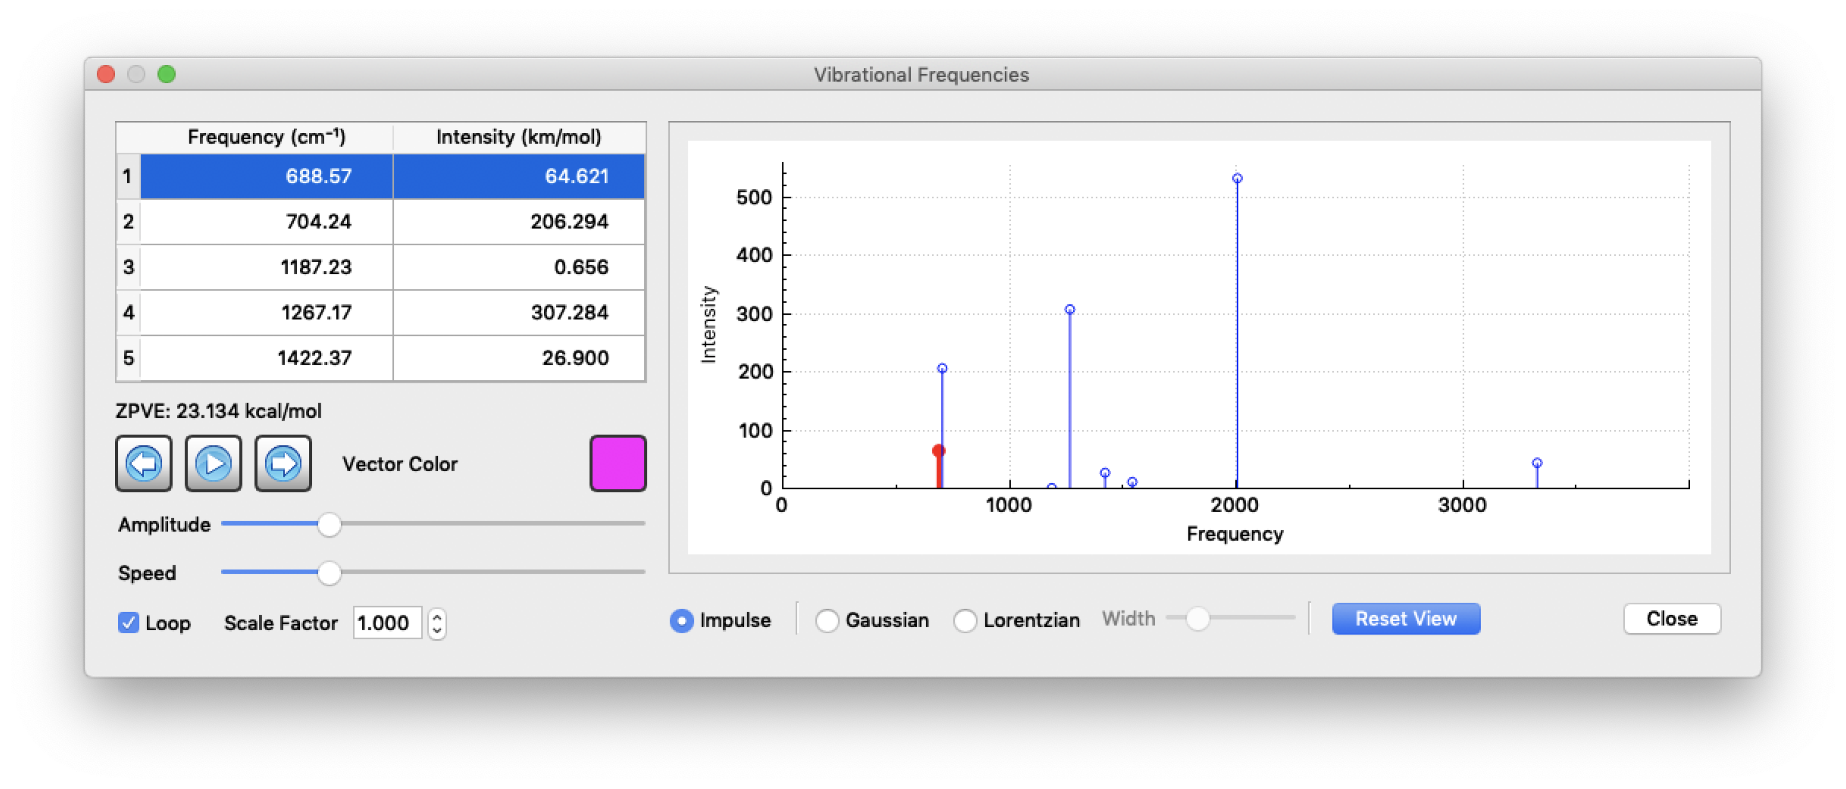

This gives you a ‘stick’ spectrum for the vibrational fundamentals of formic acid as well as controls for the animations of the vibrational modes. It also gives you the zero-point vibrational energy (ZPVE), which here is 22.355 kcal/mol. **One kcal/mol is 4.184 kJ/mol.** You need to record this value.

The vibrational intensities in the spectrum are calculated from the transition moment integral (2nd year) using the various harmonic wavefunctions. You can change the appearance of the spectrum by convoluting the ‘stick’ spectrum with a Lorentzian line shape, where you can use the slider to adjust the width. This simulates the ‘width’ in a real spectrum:

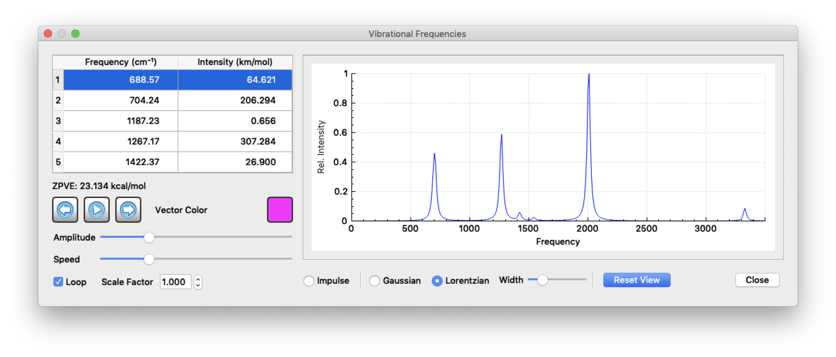

* Note that you can, at any time, use the **File > Open** menu to open and view a previous Q-Chem calculation within IQmol.

**7. Repeat for the Formic Acid Dimer**

Once you have made a starting geometry, run through the instructions above again for the dimer.

* Make another formic acid molecule and use the *option/alt* key (Mac/Windows) to add an isolated H atom that will form a hydrogen bond with the formic acid molecule you have already drawn:

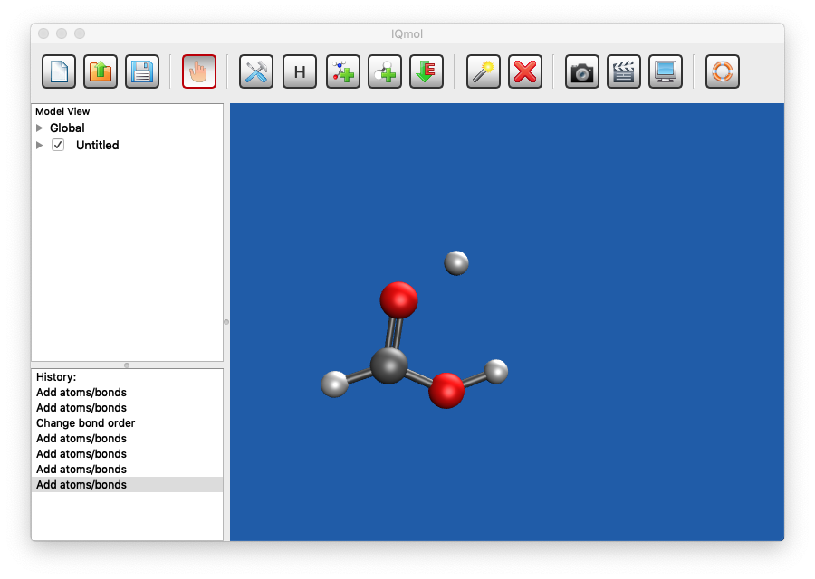

* Now complete the second formic acid so that it makes two hydrogen bonds. Don’t worry if they’re wonky like mine:

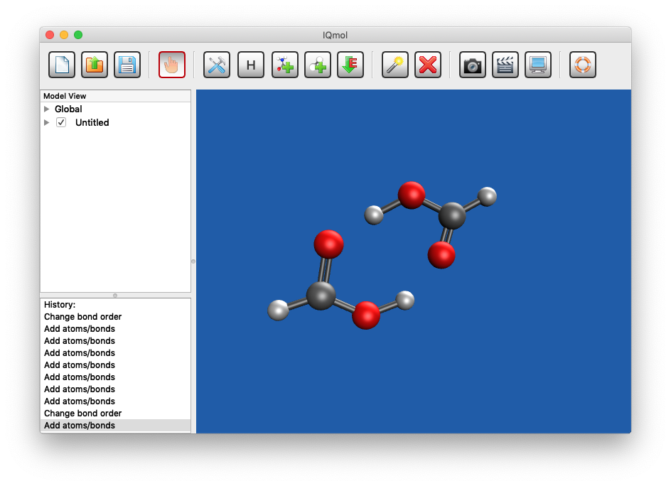

* Use the MMFF94 force field to clean up the structure and obtain something like:

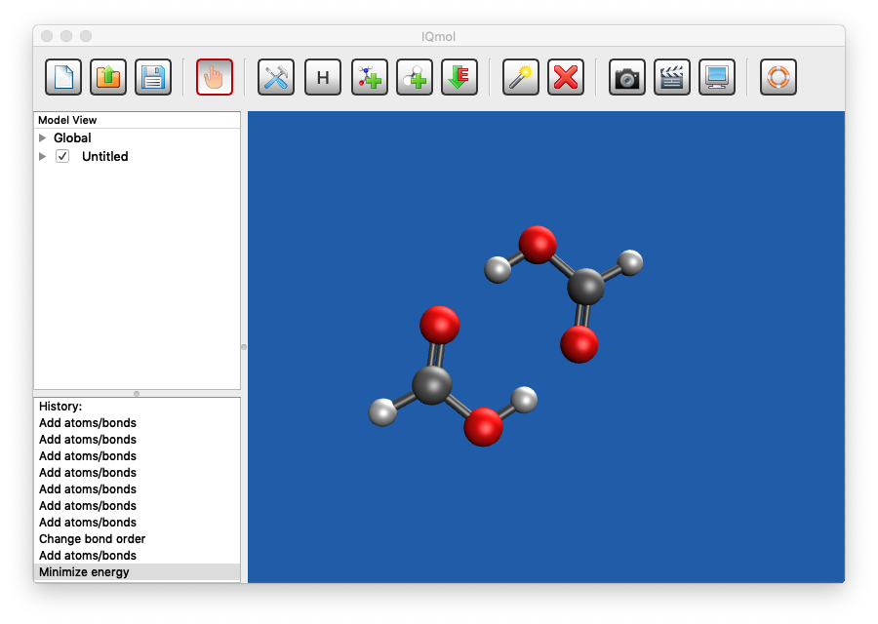

* Repeat the steps above to optimize the geometry and calculate the vibrational frequencies at the HF/6-31+G(d) level of theory for the formic acid dimer.

**8. Thermochemistry of Dimerization**

* We want the enthalpy, entropy and free energy differences for the formic acid monomer and its dimer. You need to open the output files from both of your frequency calculations and look for:

STANDARD THERMODYNAMIC QUANTITIES AT 298.15 K AND 1.00 ATM

This will be almost at the very end of the file. For **both** monomer and dimer record values for

Total Enthalpy:

Total Entropy:

These will be given in kcal/mol. **One kcal/mol is 4.184 kJ/mol.**

* Determine the total Gibbs Free Energy for the monomer and dimer from your temperature (298.15 K) and their enthalpy and entropy values.
* Determine the various values for the dimerisation process, ΔXdimerisation, that is X(dimer) – 2×X(monomer), for property X. This will let you predict, from first principles, the electronic binding energy, and the enthalpy, entropy and Gibbs free energy of dimerisation.

***Tasks:***

1. For your optimised formic acid geometry, complete Table 1 (Appendix) using your calculated vibrational frequencies and IR intensities. You may also like to animate the vibrations to more easily describe their nature.
2. Compare your results to the relevant experimental values in part A; include a critical analysis of your calculated results.
3. Complete Table 2 (Appendix), in order of increasing frequency, including a description of the 7 **most intense** formic acid dimer IR vibrational transitions and a comparison to the equivalent formic acid monomer vibrations. You should scale the vibrational frequencies by 0.89 to obtain more realistic values and compare these to experiment. There should be 4 stretching vibrations, 3 bending vibrations and 2 out-of-plane torsions (or wags) and the first row of the table is filled in as a guide.
4. Discuss your results. Why are only “antisymmetric” vibrations apparent in the formic acid dimer IR spectrum. Do the vibrational frequencies and IR intensities of the vibrations involving the hydrogen bond increase or decrease on dimerisation? Explain this in terms of the nature of the hydrogen bond. Compare your results to the relevant experimental values; include a critical analysis of your calculated results.
5. Complete Table 3 (Appendix) determining the RHF/6-31+G(d) electronic binding energy of the formic acid dimer and the RHF/6-31+G(d) enthalpy, entropy and free energy of dimerisation. *Note:* the best available calculations in the literature (at the CCSD(T)/complete basis set limit = CCSD(T)/CBS), from R. Kalescky, E. Kraka and D. Cremer, *Mol. Phys* 111, 1497 (2013), are also given in the table.
6. Discuss your results. Does the change in electronic energy favour dimerisation at the RHF/6-31+G(d) level of theory? At CCSD(T)/CBS? From your calculations, is dimerisation exothermic at 298.15 K? Is the entropy change for dimerisation positive or negative? Is dimerisation spontaneous at 298.15K? Comment on whether these results are what you would expect and how they compare with the literature calculations.

**PART 2: YOUR OWN INVESTIGATIONS**

In your remaining lab sessions, together with your lab partner, design and implement further investigations into the nature of hydrogen bonding. **Before beginning your investigative experiment**, you should check with a demonstrator that your proposed investigation is feasible and can be carried out within the appropriate time-frame. If you intend to do an experiment, even at home, you need to prepare a HIRAC for approval before beginning any experimental work and this must be signed off on by an academic member of staff.

Also note that:

* The NIST Chemistry WebBook provides a database of molecular properties, including gas and liquid phase IR spectra. It can be found at <https://webbook.nist.gov/chemistry/>).
* Experimental thermodynamic properties of many molecules and radicals can be obtained from the Active Thermochemical Tables (ATcT: <https://atct.anl.gov>).
* A compendium of computational chemistry results for many molecules using a variety of methods and basis sets can be found in the Computational Chemistry Comparison and Benchmark DataBase (<https://cccbdb.nist.gov>).

A number of suggestions for additional investigations are given below but you are not limited to these.

1. Use your phone as a camera to examine contact angles droplets of water and/or oil make with different surfaces. For example, examine the characteristics superhydrophobic surfaces such as Teflon, non-stick coatings, waxy leaves (a lotus leaf perhaps?) or, based on biomimetic principles, evaluate techniques for synthesizing surfaces and propose an appropriate experimental method.
2. Investigate how macroscopic properties (such as melting or boiling points, surface tension, viscosity etc. that you can find in the literature) are affected by the size of intermolecular interactions in series of related compounds. This could involve calculation.
3. Investigate how microscopic properties (such as IR frequencies) are affected by the size of intermolecular interactions in series of related compounds. This could involve calculation. For example, you could investigate a homologous series of compounds or, for similar molecular weight compounds, a set of molecules with different types of intermolecular interaction. To do this, you could look up experimental and/or data for dimers (analogously to the formic acid dimer) or you could do simple calculations of the binding energies and enthalpies of small dimer systems.
4. You could also investigate the effects of intermolecular forces in different phases of a substance. For example, you could look up and compare the experimental spectra of ice, liquid water and gas-phase water (or methanol, or butane, or …) and interpret the differences and similarities between these spectra.
5. Clusters are often used as a link between isolated, gas-phase, molecules and bulk liquids or solids. You could perform simple electronic structure and/or molecular mechanics calculations to elucidate the nature and binding energies of (molecule)n clusters, for molecules like water, methanol etc. How many molecules does a cluster need before its properties (e.g. the OH IR stretch region) are those of bulk liquid?
6. Intermolecular forces and surface tension gradients in solutions lead to remarkable liquid movements, known as Marangoni flows. Design an experiment (or experiments) to illustrate and characterise this behaviour.
7. Using the literature and/or simple calculations, investigate intramolecular hydrogen bonding in two isomers, for example maleic acid and fumaric acid. Predict and investigate the relative melting points and first and second acid ionisation constants of the isomers. Describe the experiments or calculations can you do to investigate the nature and strength of hydrogen bonding in these molecules?
8. The original formic acid geometry showed the OH bond in an *anti* configuration with respect to the C=O. You rotated this bond. Determine whether the *anti* configuration is also a local minimum energy structure (that is, predicted to be a stable molecule) and if so, estimate the energy difference between the conformers. If the *syn* and *anti* geometries are minima, they must be connected by a saddle point (transition state). Use your intuition to make a guess of this transition state geometry and optimize it at the HF/6-31+G* level of theory using IQmol. In this case estimate the barrier energy and discuss its implications in terms of the nature of formic acid at 298 K. You could also investigate how these energies change as you change the basis set, include electron correlation via density functional theory, or do correlated *single point energy* molecular orbitalcalculations at the HF/6-31+G* optimized geometries. NB any comparison of relative energies should include zero point vibrational energy (ZPVE) corrections.
9. The formic acid dimer you investigated was symmetric (C2h symmetry – see CHEM3X17). Do a literature search to investigate whether other structural forms are possible for the dimer. If so, optimize them at the HF/6-31+G* level of theory, compare their relative energies and hence discuss the nature of the formic acid dimer at temperatures between 30 and 60 degrees. You could also investigate how these energies change as you change the basis set, include electron correlation via density functional theory, or do correlated *single point energy* molecular orbitalcalculations at the HF/6-31+G* optimized geometries. NB any comparison of relative energies should include zero point vibrational energy (ZPVE) corrections.
10. Calculated vibrational frequencies are often scaled using *scaling factors* (see <https://cccbdb.nist.gov/vsfx.asp>). Investigate, with respect to your experimental spectra, how effective these are for formic acid and the formic acid dimer. Critically assess whether these *scaled* frequencies are accurate for all vibrational frequencies or only subsets (i.e. stretches, bends, wags, torsions). Can you develop specific scaling factors that may be appropriate to formic acid and the formic acid dimer?

***Report Instructions***

You should prepare a ***single*** report for this experiment in the *investigative experiment* report template on Canvas. It should be written individually and submitted via Canvas. Please pay attention to clarity so that your information is presented as coherently as possible. Numerical results based on experimental data should include experimental uncertainty. For any calculation, you should briefly assess the strengths and limitations of the level of theory used and suggest how it could be improved, for example a HF calculation can always be improved by including approximations to the electron-electron correlation energy. Wherever possible you should always compare your results with values from the literature.

In your report you should include the following:

1. All specific tasks listed for Part 1 above, together with a critical commentary of your analysis.

For Part 2:

1. You should provide a rationale for your investigations and a detailed experimental methods section.
2. In your overall introduction section, as well as the introduction to Part 1, you should also identify the key question(s) your additional investigation was designed to answer.
3. In your discussion, you should include all discussion points from Part 1 and also discuss the results of your additional experiment in terms of the key question(s) it was designed to answer. Where possible you should compare with literature data.
4. In your discussion you should specifically discuss the relevance of **all** of your experiments, that is Experiment A and both parts of Experiment B, to the nature of the intermolecular interactions underlying them.
5. In the discussion section of your report, using your data and by reading the literature, you should make particular reference to hydrogen bonding and comment on its importance in at least two macroscopically observable phenomena.

Please make sure you include appropriate and informative figure captions and table headings, and pay careful attention to figure formatting, in particular to units and axis labels. Details on how to prepare publication quality figures and tables can be found in the ACS Style Guide.

**Appendix Part 1, Experiment B Part 1.**

**Table 1.** RHF/6-31+G(d) calculated vibrational frequencies and infrared (IR) intensities for gas phase formic acid, together with experimental infrared frequencies.a

|  |  |  |  |  |  |
| --- | --- | --- | --- | --- | --- |
| Vibration number | Description of vibration | Vibrational frequency (cm-1) | Scaled (by 0.89) vibrational frequency (cm-1) | IR intensity (Debye2/amu-Å2) | Experimental vibrational frequencyb |
| 7 | O–C=O in plane bend | 689 | 613 | 1.53 | 625 (M) |
| 8 |  |  |  |  | 638 (S) |
| 9 |  |  |  |  | 1033 (W) |
| 10 |  |  |  |  | 1105.3 (S) |
| 11 |  |  |  |  | 1229 (W) |
| 12 |  |  |  |  | 1387 (VW) |
| 13 |  |  |  |  | 1770 (VS) |
| 14 |  |  |  |  | 2942.8 (M) |
| 15 |  |  |  |  | 3570 (M) |

a: V. Z. Williams, *J. Chem. Phys.* 15, 232; *ibid* 243 (1947); L. M. Sverdlov, *Dokl. Akad. Nauk. SSSR* *91*, 503 (1953); W. J. Orville Thomas *Disc. Faraday Soc.* 9, 339 (1950); *Research* 9, S 15 (1956); R. C. Millikan and K. S. Pitzer, *J. Chem. Phys*. 27, 1305 (1957); T. Miyazawa and K. S. Pitzer, *J. Chem. Phys.* 30, 1076 (1959); K. Nakamoto and S. Kishida, *J. Chem. Phys*. 41, 1554 (1964).

b: VW”, “W”, “M”, “S” and “VS” refer to very weak, weak, medium, strong and very strong experimental intensities, respectively.

|  |  |  |  |  |  |  |  |
| --- | --- | --- | --- | --- | --- | --- | --- |
| Description of vibration | Snapshot of normal mode for monomer | Monomer: scaled vib. frequency (cm-1) | Monomer: IR intensity (Debye2/ amu-Å2) | Snapshot of normal mode for dimer | Dimer: scaled vib. frequency (cm-1) | Dimer: IR intensity (Debye2/ amu-Å2) | Exptl. Frequency (cm-1)a |
| O–C–O in plane bend;  antisymmetric for dimer |  | 613 | 1.53 |  | 659 | 2.13 | 698 |
|  |  |  |  |  |  |  | 922 |
|  |  |  |  |  |  |  | 1218 |
|  |  |  |  |  |  |  | 1364 |
|  |  |  |  |  |  |  | 1746 |
|  |  |  |  |  |  |  | 2939 |
|  |  |  |  |  |  |  | 3084 |

**Table 2.** RHF/6-31+G(d) calculated vibrational frequencies and infrared (IR) intensities for gas phase formic acid monomer and dimer, together with experimental infrared frequencies for the 7 most intense transitions.a

a. F. Kollipost, R. W. Larsen, A. V. Domanskaya, M. Nörenberg, and M. A. Suhm, *J. Chem. Phys.* 136, 151101 (2012).

**Table 3.** RHF/6-31+G(d) thermodynamic properties of the formic acid monomer (M) and dimer (D), compared to the best literature calculations.a

|  |  |  |  |  |
| --- | --- | --- | --- | --- |
|  | RHF/6-31+G(d) | | | CCSD(T)/CBS |
| Property, X | Monomer,  X(M) | Dimer,  X(D) | Xdimerisation   = X(D) – 2×X(M) | Xdimerisation   = X(D) – 2×X(M) |
| Electronic Energy | Hartree | Hartree | Hartree  kJ/mol | -78.3 kJ/mol |
| Enthalpy (kJ/mol) |  |  |  | -71 |
| Entropy (J/mol/K) |  |  |  | -334 |
| Gibbs Free Energy (kJ/mol) |  |  |  | -22.8 |

a. R. Kalescky, E. Kraka and D. Cremer, *Mol. Phys* 111, 1497 (2013).